Acknowledgements
To Leonard Hayflick for his patience and attention that he bestowed through analyzing and correcting this hypothesis. But most of all for his ingenious paper (Hayflick L., 2021). For the second time he has given hope for finding the main reason for aging.

Cover letter
From my early academic years I have been working on the aging hypothesis. In the year 2005 my hypothesis was first published. In the manuscript that I present to you my early hypothesis of aging has developed into the theory of aging and is being elaborately explained.
In 2017 I conducted a clinical trial on 64 volunteers, the purpose of the study was to investigate the senolytic effect of dasatinib and quercetin by means of partial elimination of senescent cells. Here is the list of my earlier publications in this area:

- Dasatinib and Quercetin: Short-term Simultaneous Administration Yields Senolytic Effect in Humans: Issues and Developments in Medicine and Medical Research, DOI:10.9734/bpi/idmmr/v2/15155D
- J Tkemaladze, D Apkhazava; Dasatinib and Quercetin: Short-Term Simultaneous Administration Improves Physical Capacity in Human; Journal of Medicine and Health Care; 2019
- Konstantin Chichinadze, Ann Lazarashvili, Jaba Tkemaladze: RNA in centrosomes: Structure and possible functions. Protoplasma 06/2012; 250(1)., DOI:10.1007/s00709-012-0422-6
- Konstantin Chichinadze, Jaba Tkemaladze, Ann Lazarashvili: Discovery of Centrosomal RNA and Centrosomal Hypothesis of Cellular Ageing and Differentiation. Nucleosides Nucleotides & Nucleic Acids 03/2012; 31(3):172-83., DOI:10.1080/15257770.2011.648362
- K Chichinadze, J Tkemaladze, A Lazarashvili, A new class of RNAs and the centrosomal hypothesis of cell aging. Advances in Gerontology 2 (4), 287-291
- J Tkemaladze, K Chichinadze: Centriole, Differentiation, and Senescence. Rejuvenation Research 04/2010; 13(2-3):339-42., DOI:10.1089/rej.2009.0904
- KN Chichinadze, DV Tkemaladze: Centrosomal hypothesis of cellular aging and differentiation. Advances in gerontology = Uspekhi gerontologii, 2008
- J V Tkemaladze, K N Chichinadze: Centriolar Mechanisms of Differentiation and Replicative Aging of Higher Animal Cells. Biochemistry (Moscow) 12/2005; 70(11):1288-303., DOI:10.1007/s10541-005-0261-6
- J Tkemaladze, K Chichinadze: Potential role of centrioles in determining the morphogenetic status of animal somatic cells. Cell Biology International 06/2005; 29(5):370-4., DOI:10.1016/j.cellbi.2005.03.003

The manuscript in question is of essence for several reasons:

- As it is commonly known cancer is the disease that has the second highest rate of mortality after cardiovascular diseases, and the number of deceased is growing yearly. The scientists and WHO are putting a huge effort on finding a cure, so far the result is not the one that many aspire to. The manuscript offers a different perspective on the disease.
- Nowadays senescence and cancer are the diseases that go hand in hand, and finding a cure to one opens up the solutions to another. The molecular mechanisms of transmission of senescent cells into cancer cells is still unknown. Therefore senescence and cancer are the primary focus of the manuscript.
- The most important of all, the mechanism of cell differentiation and division has many questions that are left unanswered up until this day. The manuscript makes an attempt to unveil the very mechanism.

Statements and Declarations
o Ethics approval and Consent to participate: not applicable
o Consent for publication: not applicable
o Availability of data and materials: not applicable
o Competing interests: The authors have no relevant financial or non-financial interests to disclose.
o Funding: The authors declare that no funds, grants, or other support were received during the preparation of this manuscript.
o Authors' contributions: All authors contributed to the study conception and design. Material preparation, data collection and analysis were performed by Jaba Tkemaladze. The first draft of the manuscript was written by Jaba Tkemaladze and all authors commented on previous versions of the manuscript. All authors read and approved the final manuscript.
Conflict of interest
We the undersigned declare that this manuscript is original, has not been published before and is not currently being considered for publication elsewhere.

We confirm that the manuscript has been read and approved by all named authors and that there are no other persons who satisfied the criteria for authorship but are not listed. We further confirm that the order of authors listed in the manuscript has been approved by all of us.

We understand that the Corresponding Author is the sole contact for the Editorial process. He/she is responsible for communicating with the other authors about progress, submissions of revisions and final approval of proofs.
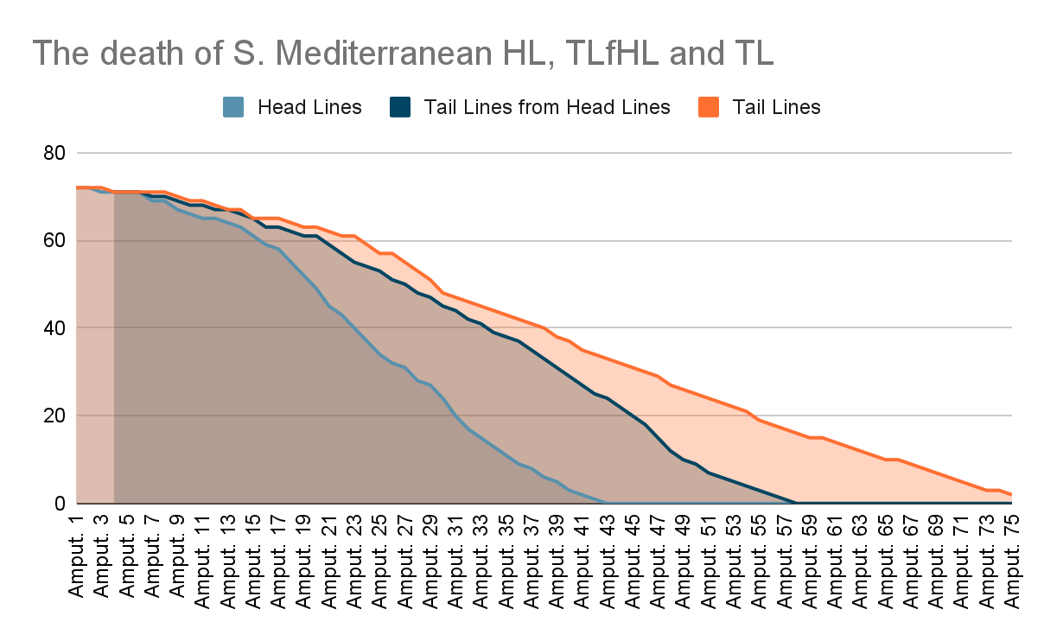

Signed by all authors as follows: Jaba Tkemaladze

